University of Maryland, Baltimore

School of Graduate Studies

Electronic Dissertation and Thesis Style Guide

INTRODUCTION
This Electronic Dissertation and Thesis Style Guide is intended to assist you in the preparation of your Doctoral Dissertation or Master’s Thesis, the final requirement for your degree. The School of Graduate Studies at the University of Maryland, Baltimore (UMB) maintains specific requirements as to the format and appearance of its dissertations and theses; such requirements assure a standard of uniformity and aesthetic consistency commensurate with the rigorous academic principles of the University. In previous years, these formatting requirements were determined primarily by the restrictions associated with the process of printing and binding the documents for publication. Dissertations and theses completed in accredited Doctoral programs are published by ProQuest through an exclusive arrangement with the Library of Congress.
These documents also may be published electronically by the UMB Digital Archive.
The flexibility of electronic publishing—fast becoming the standard for dissertations and theses
—enables the School of Graduate Studies to determine its own standards, independent of the printing process. This guide will assist you in creating a dissertation or thesis that conforms to those standards. Through an arrangement with ProQuest, the University of Maryland, Baltimore accepts dissertations and theses in electronic format. Under this arrangement, students submit an electronic version of their dissertation or thesis directly to ProQuest / UMI via the World Wide Web. Officials from the School of Graduate Studies then review the document online and request revisions by e-mail, if necessary.

BEFORE YOU PREPARE YOUR DRAFT
- Understand the Formatting Requirements in this document, the UMB Electronic Dissertation and Thesis Style Guide. This Style Guide outlines the formatting elements that the School of Graduate Studies requires for your thesis or dissertation. Do not use a previously published University of Maryland, Baltimore dissertation or thesis as a model. Format requirements have changed. Please note that the formatting requirements of the School of Graduate Studies supersede guidelines in any other style manual.
- Choose An Appropriate Style Manual. The Style Guide does not offer guidelines for formatting all elements of the document; it only outlines elements required by the School of Graduate Studies at UMB. For all other elements, such as reference format, please default to the standard style manual in your discipline. To determine the preferred style manual in your discipline, consult your advisor or program director. Refer to a style manual for systems of scholarly reference, setting off direct quotations, numbering figures and tables, presentation of data, and similar features. In general, it is advisable to become familiar with a professional style manual at this time in your academic career, if you have not already done so. The academic style manuals listed below may be of use to you as you format your thesis or dissertation. For the citation of references and any formatting element not specifically mentioned in this Style Guide, please follow the guidelines in the manual below that is most appropriate to your discipline.

  - American Medical Association. Manual of Style: A Guide for Authors and Editors. 9th ed. Baltimore: Williams & Wilkins, 1998.
  - American Sociological Association. American Sociological Review.
The Bluebook: A Uniform System of Citation. 17th edition. Cambridge: Harvard Law Review Association, 2000.
  - The Chicago Manual of Style, 14th ed. Chicago: University of Chicago Press, 1993.
  - Council of Biology Editors. Scientific Style and Format: The CBE Manual for Authors, Editors, and Publishers. 6th ed. New York: Cambridge University Press, 1994.
  - Dodd, Janet S., ed. The ACS Style Guide: A Manual for Authors and Editors. Washington, D.C.: The American Chemical Society, 1997.
  - Publication Manual of the American Psychological Association, Seventh Edition (2020) (apa.org)
  - Rubens, Philip, ed. Science and Technical Writing: A Manual of Style. New York: Holt, 1994.
  - Turabian, Kate. L. A Manual for Writers of Term Papers, Theses, and Dissertations. 6th ed. Chicago: University of Chicago Press, 1996.
  - Walker, Janice R., and Todd Taylor. The Columbia Guide to Online Style. Columbia UP, 1998.

Student Integrity
Conferral of a degree implies in part the graduate’s personal integrity and ability to perform within the framework of scholarly methods. There are three areas in which graduate students should be particularly cautious: the proper acknowledgment of cited works; the use of others‟ copyrighted material; and proper reporting of work subject to federal compliance regulations (e.g., use of human subjects, animal care, radiation, legend drugs, recombinant DNA, or the handling of hazardous materials).

Plagiarism is the intentional or knowing representation of the words, ideas, or work of others as one's own in an academic exercise. The appropriation of the language, ideas, or thoughts of another and representation of them as one's own original work. Plagiarism is a violation of the Student Academic Misconduct Policy and the UMB Policy and Procedures Concerning Misconduct in Scholarly Work.
Obtain Written Permission for Using Copyrighted Material. The U.S. Copyright Act of 1976 established the concept of "fair use" of copyright material in published work, but it does not provide absolute guidelines. Although ProQuest will publish your thesis or dissertation, ProQuest does not have the responsibility of seeking permissions for you. ProQuest uses The Chicago Manual of Style definition of “fair use.” You must become familiar with the concepts outlined there. Generally, the use of a complete unit (a poem, journal article, photograph, map, letter, and so on) requires permission. It is more difficult to define at what point a lengthy excerpt exceeds fair use. Good judgment will tell you that reproducing a significant proportion of another author's work is not "fair." However, be aware that "fair use" also touches on scholarly ethics or the use to which the quotation or excerpt will be put in your work. Another author's work should not be used as a substitute for your own analysis and argument. When in doubt,

seek permission; it is usually granted. For a sample letter requesting reprint permission, please see page 21. Granted permissions can be added as supplemental files during the submission process. If you have published your own work in a journal, you must seek permission to use it from the journal publisher who holds the copyright.

Obtain Permission for Use of Human or Animal Subjects. Prior to undertaking research using human or animal subjects, you must obtain approval. The University of Maryland, Baltimore Human Research Protections Program and Institutional Review Board Investigator Manual contains detailed instructions concerning principles, policies, regulations, and obligations relating to human subjects research at UMB. All students and investigators considering and/or conducting research involving human subjects are responsible for knowing and applying the policies and procedures governing human subject research. The use of animals in research, teaching or other activities at the University of Maryland must be reviewed and approved by the Institutional Animal Care and Use Committee (IACUC). All students and investigators considering and/or conducting research involving animals are responsible for knowing and applying the policies and procedures governing animal care and use.
Obtain Editorial, Proofreading, or Typing Assistance. If you hire someone to prepare your draft, you should provide them with the URL of this Style Guide and discuss special disciplinary requirements for your work. Remember to engage an individual early and confirm that s/he will be able to: generate your document by the submission deadline and incorporate any subsequent changes within one week of request by the School of Graduate Studies. You should also prepare a list of correctly spelled and hyphenated technical terms and foreign words for the typist, since standard dictionaries or computer spell-check utilities will not generally include such terms. The School of Graduate Studies does not recommend particular individuals or groups to prepare your draft.
The Writing Center offers individual help with brainstorming ideas, organizing structure, writing a draft, and revising and polishing prose. The Writing Center can also provide information on English as a Second Language Courses (ESL) for international students for whom English is not their first language, yet who must present their thesis or dissertation in English. The ultimate responsibility for the language, style, grammatical correctness, editing, and proofreading of your thesis or dissertation rests with you, the author.

Investigate Possible Patent and Public Disclosure Issues. A significant number of invention disclosures submitted by graduate students are related to materials contained within that student's thesis or dissertation. If your thesis or dissertation describes a new technology, any publication (digital or otherwise), presentation, or public posting—such as submission to ProQuest and the UMB Digital Archive—may be considered a “public disclosure” of the invention. If such public disclosure is made prior to applying for a patent, certain patent and intellectual property rights may be compromised.

It is the responsibility of the author to notify the Office of Technology Transfer of such submission if the work has been, or will be, submitted in part or in its entirety as an invention disclosure.

PREPARING YOUR DRAFT
Since the University of Maryland, Baltimore accepts theses and dissertations in electronic format, this Style Guide is focused on assisting your preparation of an electronic file that
conforms to the standards set by the School of Graduate Studies. This electronic file will be submitted directly to ProQuest and evaluated by the School of Graduate Studies online.

The final electronic file that you submit to ProQuest and The School of Graduate Studies
must meet the following conditions:
- Be submitted in PDF format. Conversion utilities for Microsoft Word (.doc) and Rich Text Format (.rtf) documents are available.
- Be in an approved font. The School of Graduate Studies strongly recommends Times New Roman 12.
- Have acceptable margins, line spacing, page numbering, and page layout.
- Contain all required Formal Elements of the Dissertation/Thesis.

Language
Text and references must be in English. Prior approvals from the committee, department chair, and dean of the School of Graduate Studies are required for the text to be in an alternate language.

File Format and Conversion
ProQuest requires that the final document be submitted in Adobe Portable Document Format (PDF). Microsoft Word (.doc) and Rich Text Format (.rtf) files are easily convertible to PDF documents using conversion utilities provided on the ProQuest submission site. Conversion programs other than the ProQuest conversion tool are strongly discouraged due to pagination problems. Microsoft software, including Microsoft Word, is widely available, and is present on most UMB-owned computers. Most commercially available word processing software packages, including WordPerfect (versions 6.0 and above) have the capability to save in Rich Text Format (.rtf); this is a text-based format that allows for the use of features such as bolding, italics, and underline. The PDF document that ProQuest receives is the document that will be published; take appropriate steps to ensure that the PDF you submit accurately reflects your work.
No matter what method you choose for preparing your draft, back up your work on at least two different disks. Keep those disks in safe places. It is often advisable to make CD Rom archive copies of your work.

Font / Type Style
The same font should be used throughout the Dissertation for text, headings, captions, labels, and references; the School of Graduate Studies strongly recommends using Times New Roman 12, a widely accessible standard font that will minimize software and reader compatibility problems. For symbols, use Symbol 12 or a symbol font compatible with your base font. Tables, captions, and footnotes should use the same font face, but can be in a smaller size but no smaller than 10. You may create chapter and section headings that are three points larger than your standard typeface at your discretion. While the School of Graduate Studies strongly recommends Times New Roman 12, Courier 10 is acceptable as well. Fonts that are accepted by the School of Graduate Studies:
- Courier 10
- Times New Roman 12
- Symbol 12

Margins
Each page must have at least 1.25" left and right margins, and 1" top and bottom margins (except the Title page). Please note that ALL text, tables, figures, captions/legends must fit within these margins on all pages including the CV, body, appendices. See instructions on page 14.

Justification
Type may be left justified, which leaves a “ragged right” margin (as is used in this manual), or may be full-justified, which establishes even margins on the left and right. See instructions on page 15.

Line Spacing
Each page must be double-spaced, with the following exceptions:
- Front matter such as the Title Page, Table of Contents, Lists of Tables and List of Figures may be single-spaced.
- Tables within the text may be single-spaced.
- Extended citations within the text may be set off and single-spaced. Consult your style manual for details.
- Definitions within glossaries or questions within surveys may be single-spaced, but double- spaced between entries. Scholarly references--footnotes, endnotes, bibliography or list of references--may be single-spaced, but double-spaced between entries.

Page Number Placement
All lower-case Roman and Arabic numerals page numbers must appear at the bottom center of the page. Formatting instructions are on page 15.

Widows and Orphans
A “widow” is a short line or single word ending a paragraph at the top of the next page. An “orphan” is a heading or subheading that appears at the bottom of a page with the text beginning on the following page. These are not desirable for reasons of aesthetics and
readability, although they are not prohibited. Word processing software can be set to avoid both “widows” and “orphans” automatically.

Chapters
Begin each chapter on a new page and number the page consecutively. Do not use a secondary page numbering system for sections within chapters.

The Formal Elements: Abstract, Title Page, Lists, Tables, and Appendices
The formal elements are described below. The Abstract, Title Page, Copyright Page, and Table of Contents must be formatted in the method described; other pages, as long as they adhere to the previously stipulated requirements (font, margins, justification, etc.) may be designed as the author deems appropriate.

Elements of a Thesis or Dissertation
Some elements of a thesis or dissertation are required, while others are optional. The items used in your thesis or dissertation must appear in the following order and must include the appropriate page margins, line spacing, and page numbers, as listed below.

Element | Mandatory? | Margins of a least | Line Spacing | Page Number at Bottom Center of Page
1. Curriculum Vitae | Yes | 1-inch top, bottom; 1.25-inch left, right | Varies | None
2. Abstract | Yes | 1-inch top, bottom; 1.25-inch left, right | Double | None
3. Title Page | Yes | 4-inch top;  1-inch bottom; 1.25-inch left, right | Single | None
4. Copyright Statement | No | 1-inch top, bottom; 1.25-inch left, right | Single | None
5. Preface | No | 1-inch top, bottom; 1.25-inch left, right | Varies | iii
6. Foreword | No | 1-inch top, bottom; 1.25-inch left, right | Varies | Next lower case Roman numeral
7. Dedication | No | 1-inch top, bottom; 1.25-inch left, right | Varies | Next lower case Roman numeral
8. Acknowledgements | No | 1-inch top, bottom; 1.25-inch left, right | Double between entries | Next lower case Roman numeral
9. Table of Contents | Yes | 1-inch top, bottom; 1.25-inch left, right | Double between  chapters/ major sections | Next lower case Roman numeral
10. List of Tables | Yes, if one or more tables | 1-inch top, bottom; 1.25-inch left, right | Double between entries | Next lower case Roman numeral
11. List of Figures | Yes, if one or more figures | 1-inch top, bottom; 1.25-inch left, right | Double between entries | Next lower case Roman numeral
12. List of  Abbreviations | Yes, if more  than one page of abbreviations | 1-inch top, bottom; 1.25-inch left, right | Double between entries | Next lower case Roman numeral
13. Body of Text | Yes | 1-inch top, bottom; 1.25-inch left, right | Double | 1
14. Appendix | No | 1-inch top, bottom; 1.25-inch left, right | Varies | Next consecutive Arabic numeral
15. Glossary | No | 1-inch top, bottom; 1.25-inch left, right | Double between entries | Next consecutive Arabic numeral
16. References | Yes | 1-inch top, bottom; 1.25-inch left, right | Double between entries | Next consecutive Arabic numeral
17. Index | No | 1-inch top, bottom; 1.25-inch left, right | Double between entries | Next consecutive Arabic numeral

FRONT MATTER
Curriculum Vitae (C.V.)
(Required; not numbered). Inclusion of your academic curriculum vitae is mandatory. It must have the same page layout as the rest of the thesis or dissertation, including margins. Include a permanent e-mail address that you will continue to use after your graduation. Your CV should NOT contain any personal information, such as your date of birth, home address, social security number, or signature. Zoom in to view sample below.

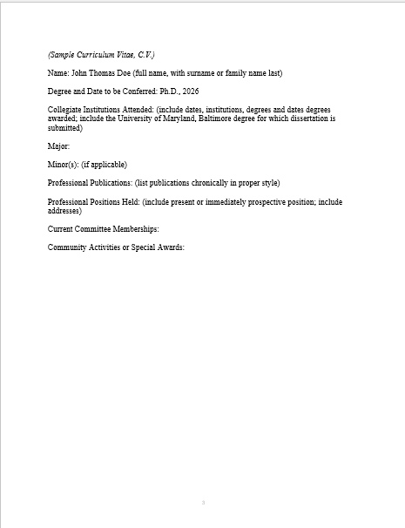

Abstract
(Required; not numbered; double-spaced). Your abstract provides a summary of the thesis or dissertation. Its purpose is to convey the essence of your work to those who may not wish to read the entire document. An abstract includes a statement of the problem, a summary of methods or procedures, the results, and the conclusions. The abstract must be in English.

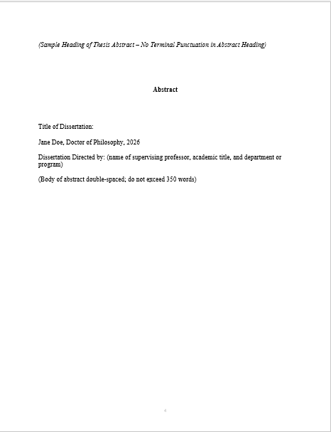

Title Page
(Required; not numbered). The title page must include the following information:
- the full title of your thesis / dissertation in title case,
- your name as it appears in university records,
- the year of the degree (not month or day),
- a standardized degree statement typed in inverted pyramid form (given below)

Your thesis or dissertation title must appear in title case or headline style. Capitalize the first word, and all other words, except for articles, prepositions, and conjunctions. Example, “The Vitamins Are in My Fresh California Raisins” Word your title very carefully. Electronic databases, citation indices, and bibliographies search using key words, so choose terms carefully to reflect accurately the content of your thesis or dissertation. Be sure that the title is exactly the same on the abstract and title page. The title page must not include italics, unless foreign words or botanical terms form part of the title itself. Do not use abbreviations. Formulas, symbols, superscripts, Greek letters or chemical names must be expressed as words wherever this is possible and be consistent with disciplinary standards. See sample Title Page below.

Standard Degree Statement
Use the following wording, inserting the correct degree title and the year (only the year) of your graduation, and typing in inverted pyramid style:
For a Doctoral Dissertation:
Dissertation submitted to the Faculty of the School of Graduate Studies of the University of Maryland, Baltimore in partial fulfillment
of the requirements for the degree of Doctor of Philosophy
202_
For a Master’s Thesis:
Thesis submitted to the Faculty of the School of Graduate Studies of the University of Maryland, Baltimore in partial fulfillment
of the requirements for the degree of Master of Science
202_
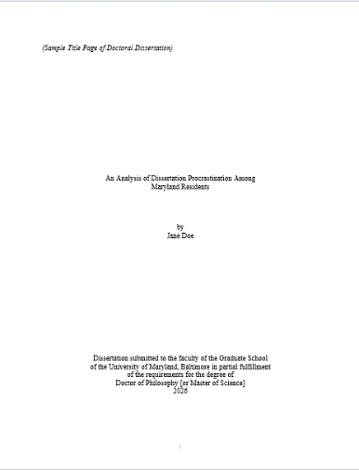
3.5”
5”
8”

Copyright Page
(Recommended; not numbered). Candidates may register their copyright on theses or dissertations. This process can be done through the electronic submission process (via ProQuest) or through the Library of Congress. Follow the directions on the ProQuest website when you submit your document to have ProQuest register copyright on your behalf, or visit http://www.loc.gov for information on registering directly with the Library of Congress. You may not change your decision to file for a copyright after you upload your document. See sample copyright page below.
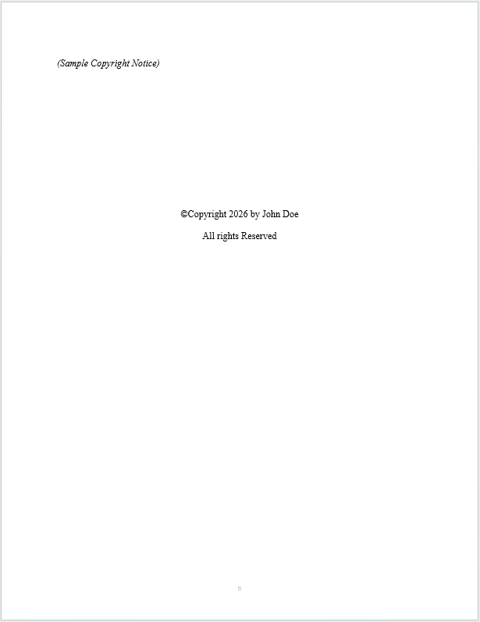

1”

Preface or Foreword
(Optional; if used, begin numbering using lower-case Roman numeral iii)
According to The Chicago Manual of Style, a Foreword includes a statement about the work by someone other than the principal author. A preface is a statement of the author’s reasons for undertaking the work and other personal comments that are not directly germane to the materials presented in other sections of the thesis/dissertation. There is no length limit.

Dedication
(Optional; if used, begin numbering using lower-case Roman numeral iii or next sequential Roman numeral)
A dedication is an honorific statement from the author to a person or group to whom the author commends the effort and product of the dissertation. Most dedications are short statements of tribute beginning with “To….” No heading is required on the dedication page. The text of short dedications should be centered between the left and right margins. There is no length limit.

Acknowledgements
(Optional; if used, begin numbering using lower-case Roman numeral iii or next sequential Roman numeral)
Acknowledgements are the author's statement of gratitude to and recognition of the people and institutions that helped the author's research and writing. There is no length limit.

Table of Contents
(Required; begin numbering using lower-case Roman numeral iii or the next appropriate lower- case Roman numerals).
A table of contents is required in all theses and dissertations. Most word processing software allows you to mark each chapter heading and subsection in the text and then generate a table of contents automatically with correct page numbers retained. Most software-generated tables of contents would be acceptable.

You may single-space between chapter subheadings, but be sure to double-space between
chapters or major sections. The School of Graduate Studies requires dot leaders (….) on each entry.

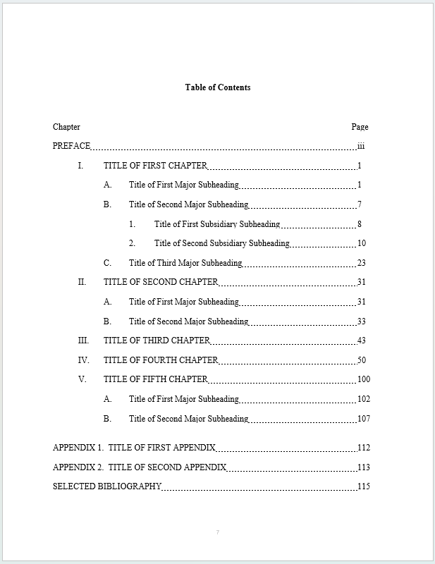
Please note that the numbering of the entries in the table of contents must be absolutely consistent with any numbering system used in the text. Thus, if your number subheadings within Chapter 1 as 1.1, 1.2, and so on, this same numbering must be used in the table of contents. You need not number or label subheadings, however. See page 18 for instructions to create a table of contents in MS Word. See below for a sample table of contents.
1”

List of Tables
(Required if one or more tables; number consecutively following the Table of Contents using lower-case Roman numerals). A table includes written material or data, whereas a figure refers to non-textual illustrative material. The easiest way to generate this list is to create a secondary table of contents. Use the table captions from your text to identify these in the list. Be sure all captions and numbering correspond exactly to those within the text. Check your style manual for
the preferred order in your discipline. The School of Graduate Studies requires dot leaders (….) on each entry. Remember to keep the required 1.25” left hand margin.

List of Figures
(Required if one or more figures; number consecutively following the Table of Contents using lower-case Roman numerals). A figure refers to non-textual illustrative material. The easiest way to generate this list is to create a secondary table of contents if your word processor permits. Use the figure captions from your text to identify these in the list. Be sure all captions and numbering correspond exactly to those within the text. Check your style manual for the preferred order in your discipline. The School of Graduate Studies requires using dot leaders. Remember to keep the required 1.25” left hand margin.

List of Abbreviations
(Required if one or more pages of abbreviations; number consecutively following the table of contents using lower-case Roman numerals). This list should be arranged in columns. Check your style manual for the preferred order in your discipline.

Document Length
The length of the dissertation and thesis vary according to the topic and the method of analysis, so the appropriate length will be determined by you and your committee.

A master's thesis is generally 50-100 pages, not including the front or back matter A doctoral dissertation is generally 100-250 pages, not including the front or back matter.

General Document Outline
Many dissertations and these follow the format:

Introduction
Provides an overview of the research topic, the methodology, as well as its scope and significance. A literature review sections demonstrates that expertise in the topic and understanding of previous research, including its limitations. Summarizes the current viewpoints and describes how this research relates to previous studies. Specific aims which describe the research questions may be included here or in separate chapter.

Methodology
Explaining how the research has been designed and why the research methods/population/data collection and analysis being used have been chosen; the broad philosophical underpinning to your chosen research methods, including whether you are using qualitative or quantitative methods, or a mixture of both, and why. The methodology should be linked back to the literature to explain why you are using certain methods, and the academic basis of your choice.

Results
Describes research findings; includes, tables, graphs, statistical analysis of results, often divided into multiple chapters to address each specific aim

Discussion and Conclusion
Analyzes, interprets and explains the research findings and discussing them in the context of the literature review, suggests direction for future studies

Manuscript Style Outline

Introduction
Provides an overview of the research topic, the methodology, as well as its scope and significance. A literature review section demonstrates that expertise in the topic and understanding of previous research, including its limitations. Summarizes the current viewpoints and describes how this research relates to previous studies. Specific aims which describe the research questions may be included here or in separate chapter.

Manuscripts
Reprint first author manuscripts with publisher’s permission Reference by Chapter Title footnote
Chapter Title typically is same as Manuscript title

Discussion and Conclusion
Analyzes, interprets and explains the all research findings and discussing them in the context of the literature review, suggests direction for future studies

BODY
Chapters
Begin page numbering with Arabic numeral 1 (bottom center of page) and number all subsequent pages consecutively to the end.) Do NOT use chapter or section cover sheets. The body of the thesis or dissertation should be typed continuously, double-spaced, with each new chapter beginning on a new page. The chapter title may be typed no more than 1" from the top of the page and may be typed in a font not more than three points larger than the base font.

Manuscripts
If your dissertation is in a manuscript format, include citation on the page with the chapter title, see below. In addition to your manuscripts, your dissertation will include a separate introduction, discussion and comprehensive reference list.
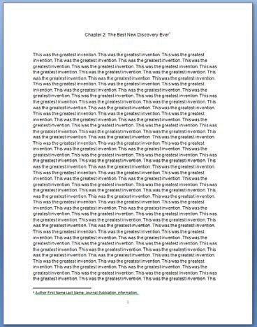
1”

Illustrations and Non-Text Elements
In this Style Guide the term "illustration" is meant to cover all non-text elements of the thesis or dissertation, such as figures, tables, maps, plates, photographs, drawings, and so on. Illustrations should be saved as picture files (.jpeg, .gif, .tiff, etc.) and inserted into the main text of the thesis or dissertation as pictures (not objects).
The main text of the dissertation must contain a reference to each illustration. Illustrations should be placed in the text as close to the first mention of the figure or table as possible—either on the same or on the following page—but never before the first reference. Do NOT place all figures or tables in one section. Illustrations must be numbered consistently in one of two ways: consecutively throughout the document (e.g., Figures 1, 2, 3 – 47) or by chapter (e.g., Figures 1.1, 1.2, 2.1, 2.2 – 5.6). Consult your style manual for a consistent numbering and identification system.

Illustrations must be listed by category in the preliminary pages (See: List of Tables, List of Figures). All illustrations must conform to the minimum margin requirements. If illustrations are larger, then use photographic reduction to achieve an appropriate size.

However, illustration captions should be consistent with the body of the thesis /dissertation text—these can be 2 points smaller than the text, but no smaller than 10 point.
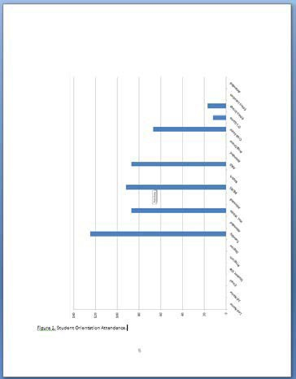
In many cases, figures, graphs, and illustrations are landscape-oriented. For landscape-oriented illustrations, save the illustration as a picture file (ex.tiff, jpeg, gif or bmp). Insert the picture file into the document and rotate it 90° counterclockwise, see image below.

Illustration Captions
All illustrations must be identified by captions, preferably on the same page. Place the caption on the preceding page, if a figure or table is too large or the caption too long for both to fit on the same page. You may place several captions (clearly labeled) on one page, to be followed immediately by the several figures. Single spacing is recommended for captions.

Other Materials
A few theses or dissertations may include video or audio tapes, films or slides, or computer or compact discs. These materials must be converted into digital format (MP3 or WMA for audio files, MPEG, AVI or QuickTime for video files) for submission to ProQuest through the electronic submission process as a supplemental file separate from the theses or dissertations. The main text of the thesis or dissertation must contain a reference to each supplemental file.

BACK MATTER

Appendices
(Optional; pages numbered consecutively with the text). Follow the recommendations in your chosen style manual for materials appropriately presented in an Appendix rather than in the body of the text. The main text of the thesis or dissertation must contain a reference to each appendix. You may have multiple appendices, which must be labeled consecutively (A, B, C, etc. or I, II, II, etc., as appropriate to your discipline). Cover pages may not be used. Be sure to include all appendices in your Table of Contents.
An original survey instrument prepared in a typeface different from that of the thesis or dissertation is acceptable. Information containing identifying information of human subjects is prohibited.

If used, scanned supporting materials reproduced from other sources (with permission) must meet the same requirements for margins and clarity as the rest of the theses or dissertations. Copies from books, journals, maps, and so on must be completely clean and legible. Residual shadows from page edges, as may be created in the process of scanning, are not acceptable.

Scholarly References
(Mandatory; pages numbered consecutively with the text). References should be cited in the style that conforms to that normally used in scholarly journals in your field of study. The style that you select must be used consistently throughout your thesis or dissertation.
Each UMB dissertation or thesis must include a comprehensive list of references, even if such references are already included in footnotes, endnotes, or for each chapter.
Your List of References (References) or Bibliography must be placed at the end of the thesis or dissertation, regardless of what your chosen style manual recommends.

To combine all chapter references, cut and paste all references into a new document, convert to a table by recognizing paragraph breaks. Then, sort by last name, delete duplicates, convert back to text, and paste into dissertation or thesis document.

Index
(Optional; pages numbered consecutively with the text). If your thesis or dissertation features an index, place it after the reference page. Follow the format described above for optional formal elements.

Qualitative, Quantitative, and Manuscript Style Dissertation Samples
Qualitative and Quantitative Dissertation:

The Benefits and Costs of Caring: A Mixed-Methods Study of Early Head Start Home Visitors by Allison L. West

http://archive.hshsl.umaryland.edu/bitstream/10713/5047/1/West_umaryland_0373D_10695.pdf

Qualitative:
The Conceptualization of Race and Racism in the Discourse Addressing Racial and Ethnic Health Inequities by Todd Vandestine
http://archive.hshsl.umaryland.edu/bitstream/10713/5062/1/Vanidestine_umaryland_0373D_10690
.pdf

Quantitative:

Pharmacotherapeutic Management and Care Transitions among Nursing Home Residents with Atrial Fibrillation by Sarah Dutcher
http://archive.hshsl.umaryland.edu/bitstream/10713/4104/1/Dutcher_umaryland_0373D_10531.pd f

Manuscript:
The Effects of the 2011 Maryland Alcohol Sales Tax Increase on Alcohol-Impaired Drivers Involved in Fatal and Non-Fatal Crashes. By Marie-Claude Lavoie

http://archive.hshsl.umaryland.edu/bitstream/10713/5484/1/Lavoie_umaryland_0373D_10701.pdf

FORMATTING YOUR DOCUMENT WITH MS WORD
This chapter is intended as a resource to assist you in formatting your document with Microsoft Word. In this section, we address many of the technical problems students have with formatting their document; these include setting fonts, margins, and justification, as well as the (at times counter intuitive) method for using multiple page numbering schemes within a single document.

Margins
The School of Graduate Studies requires that each page of the thesis or dissertation must have
1.25" left and right margins, and 1" top and bottom margins. To set the margins of your Word document:
Choose Layout < Margins < Custom Margins:
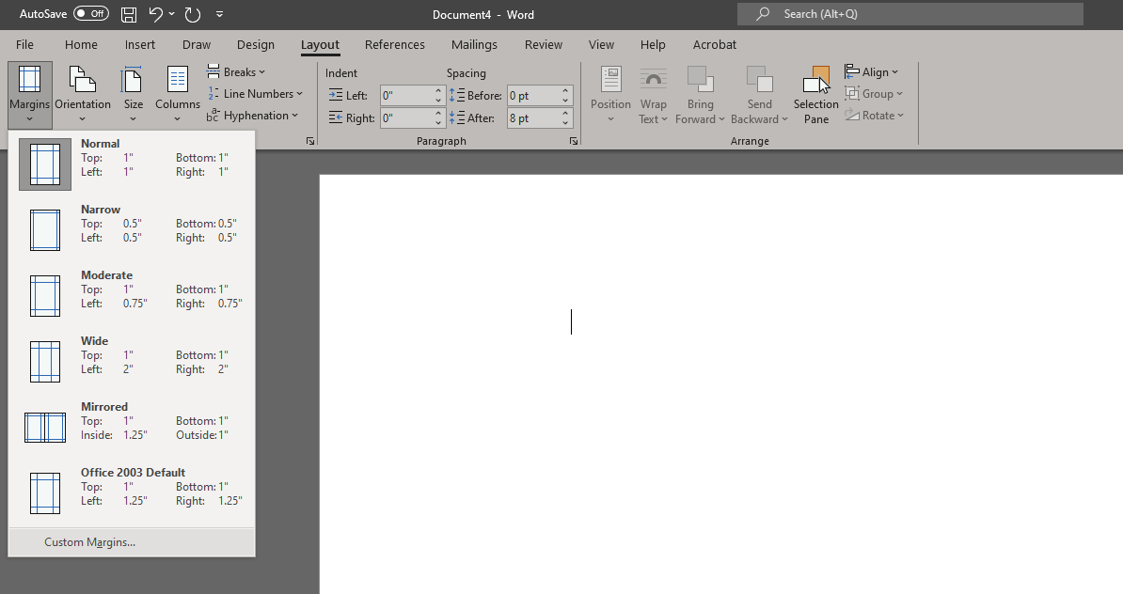

Set margins as: 1.25" left and right margins, and 1" top and bottom margins.
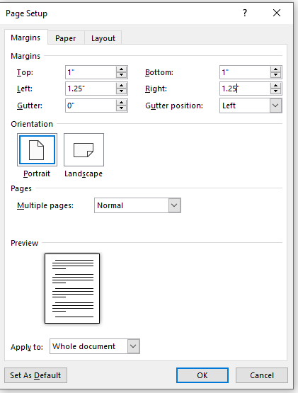

Justification
Thesis and dissertation text may be left-justified, which leaves a “ragged-right” margin (as in this document), or text may be full justified, which creates even margins on the left and right sides of the page. To change the justification of your document:

The button is for LEFT justification. The  button is for FULL justification, even margins on both sides. The button is for CENTER justification, where the text is centered on the page.
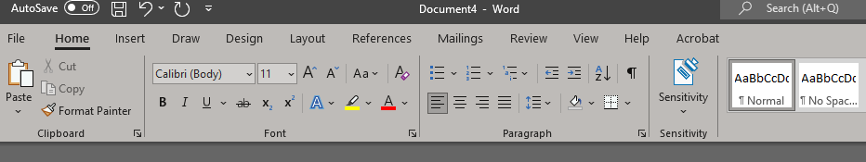

Page Numbering in MS Word
This is often the most infuriating part of formatting a theses or dissertations. The School of Graduate Studies requires three different page numbering schemes in each thesis/ dissertation:
- No Page Numbers: CV, Abstract, Title Page, and Copyright Page
- Lower-Case Roman Numerals (iii, iv, v, vi, viii): Front Matter (Preface, Foreword, Acknowledgements, Table of Contents, List of Tables, List of Figures, List of Abbreviations)
- Arabic Numerals (1,2,3,4): Main Body Text, Appendices, Glossary, References, Index
In MS Word, page numbers are properties of document subdivisions, called Sections. One Word file (a single document) can have an unlimited number of Sections; as a document author, you control how your document is subdivided into sections by inserting Section Breaks.

Each Section of your document can have different properties: layout (columns), borders and line spacing, and of course page numbering. For a UMB thesis or dissertation created in MS Word, you will need three different page numbering schemes; as such, you will need to divide your document into three sections.

Inserting Section Breaks, dividers between sections, is easy. By default, Word documents contain only one section; you will insert two breaks to divide the document into three sections, each of which will have a different page numbering scheme. First divide the document into sections, and then insert the page numbers.
Please follow the detailed instructions on the subsequent pages.

Inserting Page Numbers [For MS Word Version 2210]
- You may find it useful to Show Paragraph Marks, by clicking the paragraph symbol (¶) in the Paragraph dialog box.

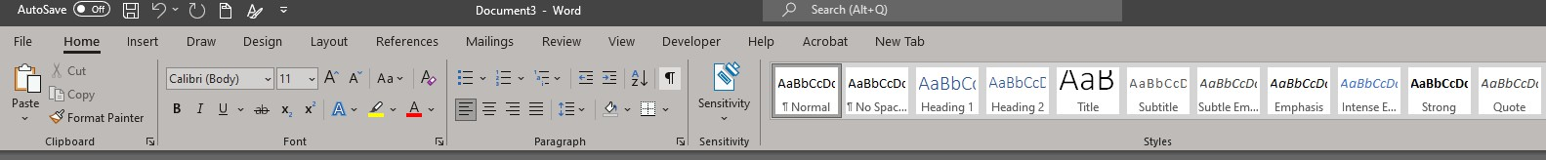

- Remove all page numbers from the document
  - Click the Insert tab.
  - Click “Page Number.”
  - Click “Remove Page Numbers.”
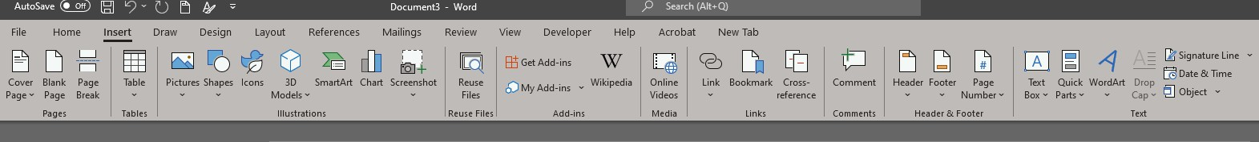
A
B

- Create Sections
  - Place cursor at the last line of text on what will be the last un-numbered page (typically the Copyright page).
  - Click the Layout tab.
  - Click “Breaks.”
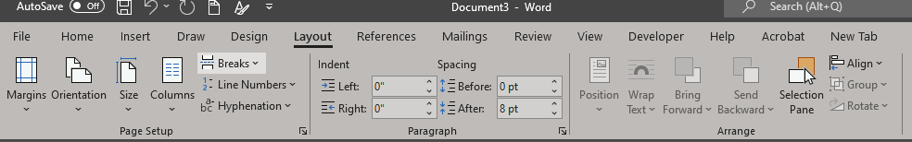
  - Click “Continuous.”
B
C

  - Place the cursor at the bottom of the last page that should have lower case Roman numerals.
  - Insert another Continuous Section Break, as described in steps C and D above.

- Insert Page Numbers
  - Go to the first page of your document.
  - Click the insert tab.
  - In the Header & Footer group, click “Page Number.”
  - Click “Bottom of Page.”
  - Select the option with the page number in the bottom center of the page.
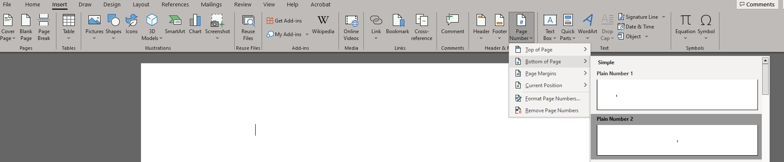
  - You should see Arabic numbers throughout your document.

D
A C

E

- Un-link Sections
  - With the Header/Footer visible, click in the footer of the first page of section 2 (first page that requires lowercase Roman numerals).
  - In the Navigation group, un-click “Link to Previous.”
  - Repeat steps A and B in the first page of body.

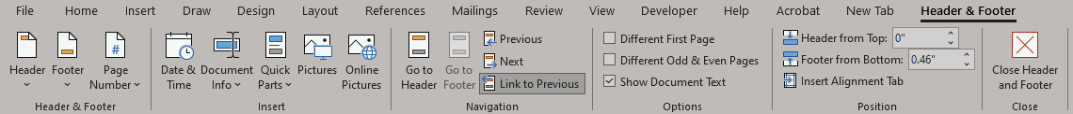
B
- Format Page Numbers
  - Go to the first page of your document (first page of CV).
    - In the footer, delete the page number using the delete or backspace key.
    - You should see no Page numbers in the first section.
  - Go to the first page of section 2 (first page that requires lowercase Roman numerals).
    - Click in the footer.
    - In the Header & Footer group, click “Page Number.”
    - Click “Format Page Numbers….” A dialog box will appear.
    - Change the Number Format to i, ii, iii, ….
    - Click “Start at” and select iii.

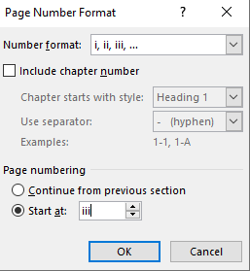
4
5

    - Click OK.
    - Section 2 should begin with iii. (Note: If using iii does not work, repeat step 5 using ii.)
  - Go to the first page of section 3 (first page of the body).
    - Click in the footer
    - In the Header & Footer group, click “Page Number”
    - Click “Format Page Numbers….” A dialog box will appear.
    - Change the number format to 1, 2, 3….
    - Click “Start at” and select 1.
    - Click OK.
    - You should see that section 3 begins with 1.
  - Save your changes.

Inserting a Table of Contents [For MS Word Version 2210]

- Create Bookmarks from Headings
  - Click the View Tab.
  - In the Document Views group, click “Outline.” A new screen layout and new options will display.
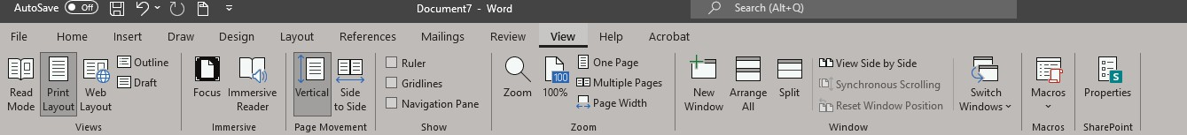
B A

  - Using the mouse, select the text of the first chapter heading.
  - Hold down the Control key and select the next chapter heading using the mouse.
  - Repeat until you have selected all chapter headings. (If you prefer, you may work on each heading individually.)
  - Select “Level 1” from the Outlining drop-down box at the top left.
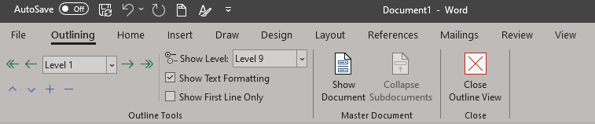

- The text color/size/style/will change.
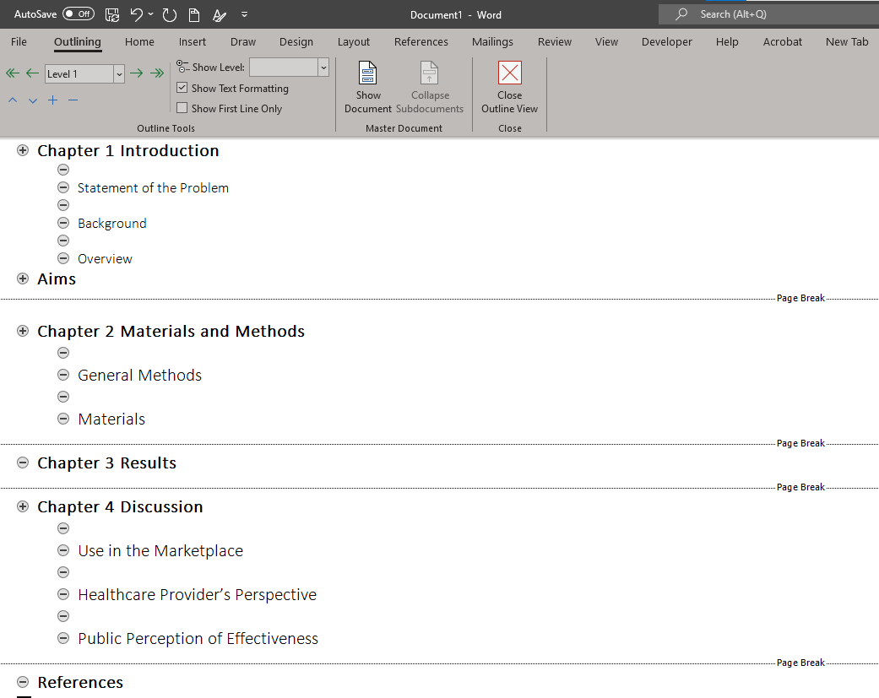

  - Repeat steps C through E to assign chapter sub-sections to Level 2, as appropriate. These subheadings will be indented, and the font formatting will change.
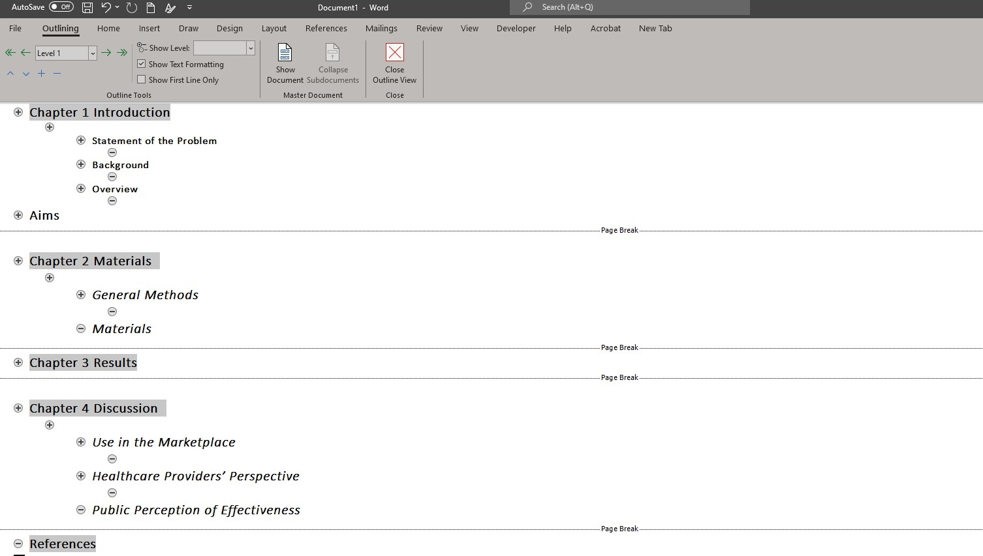
  - Click the Home Tab to view the font dialog box.
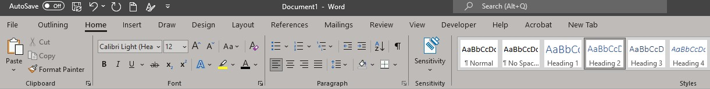
  - Change the font, font: size, style, and/or color to be consistent with the rest of your thesis/dissertation and to be in accordance with Style Guide requirements.
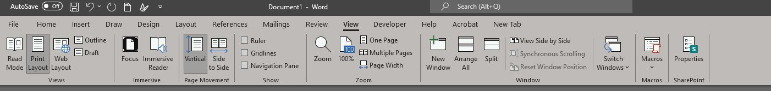
- Insert a Table of Contents

B A

Click the View Tab.
Click “Print Layout.” Your screen layout will revert to normal.
- Place the cursor where the Table of Contents should appear in the document.
- Type the heading “Table of Contents” at the top of this page.
- Click the References tab

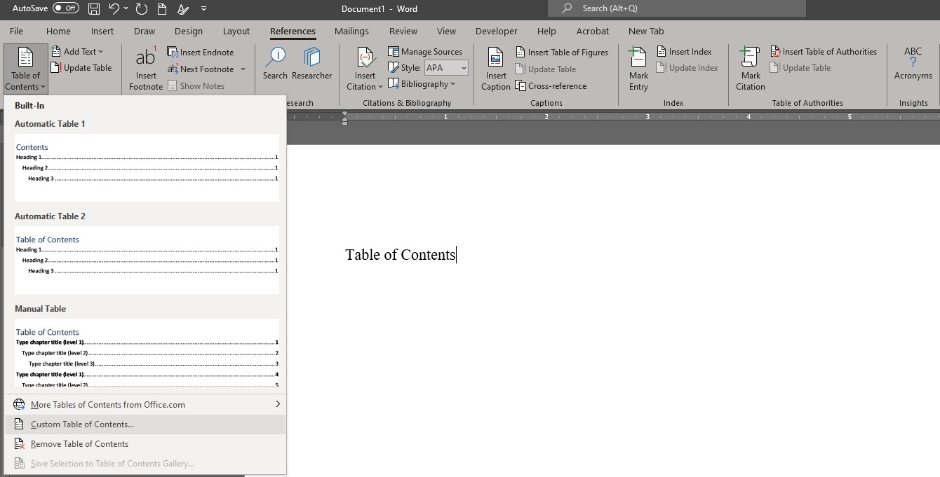
F
E
G
- Click “Table of Contents”
- Select “Custom Table of Contents” near the bottom of the drop-down list.

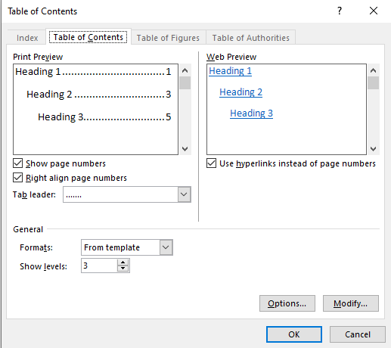
H
- Several options will display. Ensure that the following options are selected:
  - Show page numbers
  - Tab leader (...).
- Click “OK.”
- Save your changes.
~ You will see the Chapter Headings, dot leader, and page numbers appear on the Table of Contents page(s).

Note: If you make changes to your document (e.g., change chapter headings, add/delete a chapter or section, move illustrations) after inserting the Table of Contents, you will need to...
- Update the Table of Contents
  - On the References Tab, in the Table of Contents group, click “Update Table.”
  - Click “Update entire table” to include all changes to page numbers and/or headings.
  - Click “OK.”
  - Save your changes.

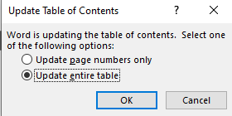
B
~ Whenever you change your document, you need to repeat steps A through D to incorporate new headings and page numbers into the table of contents.
Inserting Dot Leaders (.…) [For MS Word Version 2210]
- Select text on the Table of Contents/List of Tables/List of Figures.
- Click Layout.
- Open the Paragraph dialog box and click Tabs at the bottom left.
- Under Leader, click option 2.
- Click Set.
- Click OK.
- Place cursor after the first chapter/table/figure name and press tab. Dot leaders should appear.
- Repeat step 7 for each remaining chapter/table/figure name.
~ To insert dot leaders in other Lists, repeat the above steps on selected page(s)

Use Word’s Built-In Accessibility Checker

How to Run the Accessibility Checker
- Go to Review in the Ribbon.
- Select Check Accessibility (sometimes located under Accessibility in newer versions).
- A pane will appear on the right showing:
- Errors (must fix)
- Warnings (should fix)
- Tips (recommended improvements)

What the Checker Looks For
- Missing alt text on images
- Incorrect reading order
- Empty headings
- Low-contrast text
- Missing table headers
- Improper hyperlink formatting
- Use of repeated blank spaces or empty paragraphs

How to Use the Results
- Click any issue in the accessibility report; Word will take you directly to the problem area.
- Use the recommended actions Word provides to quickly fix issues.

SUBMITTING YOUR DOCUMENT
The University of Maryland, Baltimore has an agreement with ProQuest to accept theses and dissertations electronically. Following the guidelines in this Style Guide, you will be able to produce a document that is appropriate for submission to the University. There is NO fee to submit your thesis or dissertation electronically.

To begin the process of Electronic Submission of your thesis or dissertation, double check that your electronic file is in the proper format (Microsoft Word, Rich Text Format, or Adobe PDF), and that it conforms to the appearance standards set forth in this Style Guide. Complete all fields carefully. Your names (first, middle, last, suffix) should match all other publications and your UMB Electronic Publication Form/Digital Archive Authorization.
You may only submit your dissertation or thesis after your defense has been completed and your Dissertation Committee has submitted the Report of the Examining Committee and Approval Sheet to the School of Graduate Studies. You may not submit a draft thesis or dissertation to ProQuest; the document you submit must be identical to the one you successfully defended. The School of Graduate Studies will not evaluate any thesis or dissertation document submitted before receipt of the Report of the Examining Committee.
When you have completed the formatting of your document and confirmed the submission of the Report of the Examining Committee and the Approval Sheet, visit the ProQuest submission
site. At the top right side of the page, you will see the word “Students,” with links to “Submit” and “Revise.”
If you are logging in for the first time, click the “Submit” link. You will be prompted to create an account, and it will lead you to a logon page. Follow the directions on the site and enter the requisite information about yourself, including an e-mail account that you monitor regularly.
Enter the required information about your thesis or dissertation, entering your Abstract and accompanying information into the given form (cutting and pasting from a word processing program is acceptable), and finally uploading your thesis or dissertation.

If you have a ProQuest account, enter your log in information.

Complete the “Notes to the Administrator” (for any problems/concerns) and Copyright section (fee associated).

If you have difficulties uploading your thesis/dissertation, please contact ETD Support at etdsupport@proquest.com or 877-408-5027.
There is NO need to send an e-mail notifying the School of Graduate Studies that you have uploaded your thesis/dissertation. The School of Graduate Studies will be notified by the site of your initial upload and subsequent changes.

The School of Graduate Studies will review the PDF file for format, legibility, etc. If all standards have been met, and all paperwork has been submitted, the University will accept the thesis or dissertation and notify you via e-mail. If the University's standards have not been met, you will receive an e-mail from the “Administrator of University of Maryland at Baltimore” account detailing the formatting changes that need to be made. You would then make the changes to

your Word document and log on to the ProQuest submission site. Convert the document to a pdf and click the “Revise” link to submit your updated thesis/dissertation.

At the conclusion of the semester, all approved theses and dissertations will be sent to ProQuest for publishing, regardless of defense date. The School of Graduate Studies will notify you when your thesis/dissertation has been submitted for publishing.

Ordering Copies of Your Thesis/Dissertation
If you choose, you may purchase a bound copy of your thesis or dissertation from the publisher of your choice. ProQuest also provides this service; follow the directions on the website to purchase copies of your thesis or dissertation. This optional transaction is between you and the publisher and does NOT involve the School of Graduate Studies.
Any copies of your thesis/dissertation will be produced AFTER the thesis/dissertation has been approved and submitted for publishing by the School of Graduate Studies. Contact ProQuest will all questions regarding your order. You may call 800-521-0600 x77020 or submit your questions online.

Availability of Your Thesis/Dissertation
After the School of Graduate Studies has submitted your thesis/dissertation, for publishing, it will be available in the ProQuest database and the UMB Digital Archive. The School of Graduate Studies recommend immediate publication of the thesis or dissertation. The student may delay publication by 6 months, 1 year or 2 years.

Deadlines
The School of Graduate Studies maintains deadlines for submission of theses and dissertations for spring, summer and fall. Students must complete the submission process, i.e., upload the first version of their document (prior to any School of Graduate Studies-requested corrections), before the stated deadline to qualify for graduation in a given semester. Graduation deadlines can be found on the Calendars and Deadlines webpage.

Questions: gradforms@umaryland.edu

APPENDIX
(Sample Request for Permission to Reprint Copyrighted Materials)
Your Return Address
Date

Publisher Address
City, State, Zip Dear (Publisher):
I request permission to reprint the following material from your publication: (give complete bibliographical information for requested material in acceptable format for your discipline; include page numbers)

I have enclosed a copy of the material for your convenience.
This material will be reprinted in my dissertation, entitled Title of Your Dissertation, which I anticipate will be published (give graduation month and year).
Sincerely, (Signature) Your Name
Department
Permission to reprint the above-referenced material granted by: Name / Title:
Conditions: Signature:

Approval Sheet

Title: [title of dissertation]

Name of Candidate: [your name]
Doctor of Philosophy, [year of graduation]

Dissertation and Abstract Approved: *_________________________________________
(*signature of supervising professor)
(name of supervising professor, typed)
(rank of professor)
(name of department or program)

Date Approved: _______________

(Sample Curriculum Vitae, C.V.)

Name: John Thomas Doe (full name, with surname or family name last)

Degree and Date to be Conferred: Ph.D., 2026

Collegiate Institutions Attended: (include dates, institutions, degrees and dates degrees awarded; include the University of Maryland, Baltimore degree for which dissertation is submitted)

Major:

Minor(s): (if applicable)

Professional Publications: (list publications chronically in proper style)

Professional Positions Held: (include present or immediately prospective position; include addresses)

Current Committee Memberships:

Community Activities or Special Awards:

(Sample Heading of Thesis Abstract – No Terminal Punctuation in Abstract Heading)

Abstract

Title of Dissertation:

Jane Doe, Doctor of Philosophy, 2026

Dissertation Directed by: (name of supervising professor, academic title, and department or program)

(Body of abstract double-spaced; do not exceed 350 words)

(Sample Title Page of Doctoral Dissertation)

An Analysis of Dissertation Procrastination Among
Maryland Residents

by
Jane Doe

Dissertation submitted to the faculty of the School of Graduate Studies
of the University of Maryland, Baltimore in partial fulfillment
of the requirements for the degree of
Doctor of Philosophy [or Master of Science]
2026

(Sample Copyright Notice)

©Copyright 2026 by John Doe

All rights Reserved

(Sample Table of Contents)

Table of Contents

Chapter Page

PREFACE iii

I. TITLE OF FIRST CHAPTER 1

A. Title of First Major Subheading 1

B. Title of Second Major Subheading 7

1. Title of First Subsidiary Subheading 8

2. Title of Second Subsidiary Subheading 10

C. Title of Third Major Subheading 23

II. TITLE OF SECOND CHAPTER 31

A. Title of First Major Subheading 31

- Title of Second Major Subheading 33

III. TITLE OF THIRD CHAPTER 43

IV. TITLE OF FOURTH CHAPTER 50

V. TITLE OF FIFTH CHAPTER 100

A. Title of First Major Subheading 102

B. Title of Second Major Subheading 107

APPENDIX 1. TITLE OF FIRST APPENDIX 112

APPENDIX 2. TITLE OF SECOND APPENDIX 113

SELECTED BIBLIOGRAPHY 115

